**AI ANN Regressor Assignment 2**

**Xiao(Megan)Ling**

1. **Object**

We are going to use UCI red wine dataset predict red wine quality using an Artificial Neural Network. With given data points about Portuguese “Vinho Verde” wine, such as fixed acidity, residual sugar, etc., we will be able to determine wine qualities based on a model designed.

1. **The Final Model & Training Algorithm**

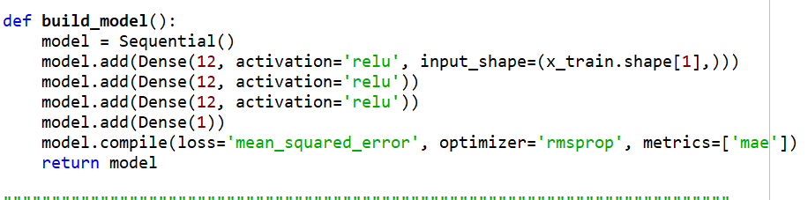

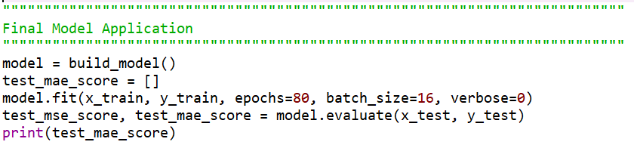

The Final Model has 3 hidden layers using RMSprop as model compile optimizer and MAE as metrics.

The training algorithm here is Artificial Neural Network Algorithms which consists of different layers with weighted connections for analyzing and learning data.

1. **The experimental plan for arriving at the final model and 5. How long it took to run all the models in your experimental plan**

Adagrad [[9]](http://ruder.io/optimizing-gradient-descent/index.html#fn9) is an algorithm for gradient-based optimization that does just this: It adapts the learning rate to the parameters, performing smaller updates  
(i.e. low learning rates) for parameters associated with frequently occurring features, and larger updates (i.e. high learning rates) for parameters associated with infrequent features.

Then I changed parameters tried K=5, Epochs =200 to see if the MAE would decrease. As the chart shows below that the Mean MAE from each training session:

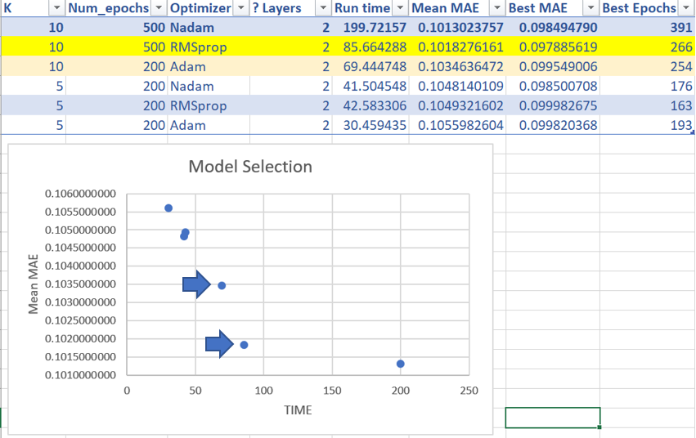

According to the results, the Best Mean MAE appears when using Nadam Optimizer with K=10 and 500 epochs. However, combined with time spend running the training model, it runs too slow compared with other training models from Adam and RMSprop has similar Mean MAE level.

To save running time, I set the number of epochs to 200, but the Mean MAE dropped dramatically. Then I ran RMSprop and Adam models with parameters K=10, Epochs =500 with 2/3 neural layers. The Scatter plot shows that based on a time efficiency rule, when K=10, Epochs =500, 3 neural layers, RMSprop has the best performance in the training data.

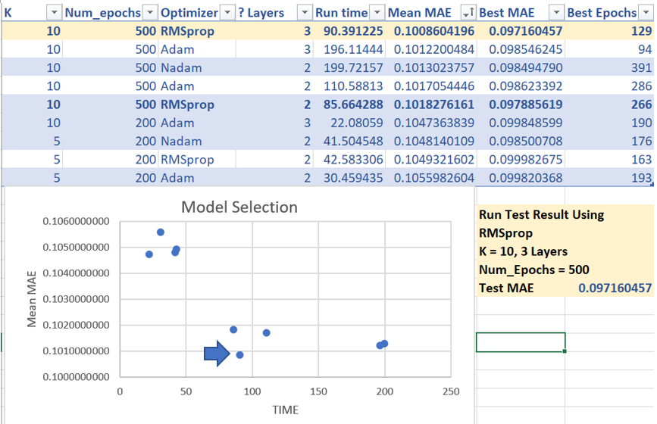As a result, I selected K=10, Epochs =500, 3 neural layers, as my parameters for the final RMSprop model.

1. **An explanation of the input variables and any preprocessing steps you took**

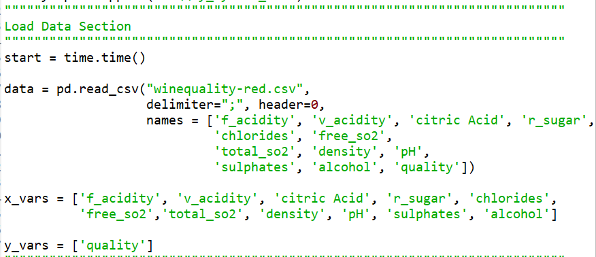I input data through “pd.read_csv” to load in red wine-quality data. Since we are going to predict the wine quality, I isolate the quality labels from the rest of the data set in “y_vars” and the rest into “x_vars.”

In the data pretreat step, I preprocess X and Y data before fitting into predictor. It will convert unscaled data into a given range. Then the data was split into train and test set into a 70/30 proportion through “train_test_split” function. To make sure the axis along which the means are computed properly, the training and test dataset mean on axis 0 will be the mean of all the rows in each column.

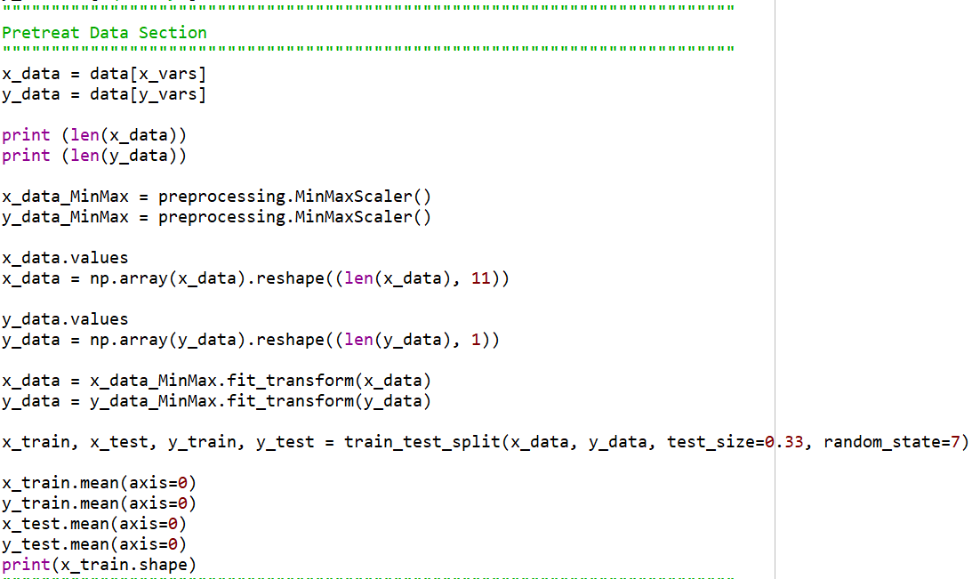

1. **An explanation of your metrics and justification for your choice**

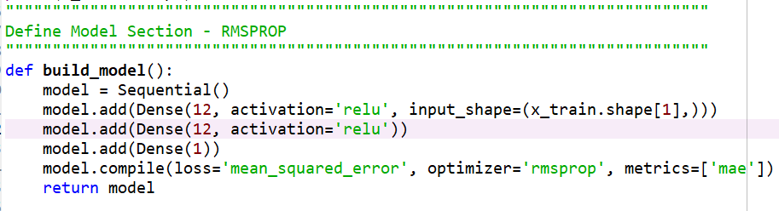

After preparing data and splitting train and test sets, it’s easy to find out the training data with a shape of 1071 rows and 11 columns by “x_train.shape.” To prevent overfitting, I selected a very small network with three hidden layers, each with 12 units. The network ends with a single unit and no activation. Since we are building up a regressor model, the network is free to learn to predict values in any range to generate a linear result. Generally, the MSE loss function is wildly applied when compiling the network. To monitor the training result, MAE metric is introduced to show the difference between the predictions and the targets.

1. **An explanation of your method to validate the model**

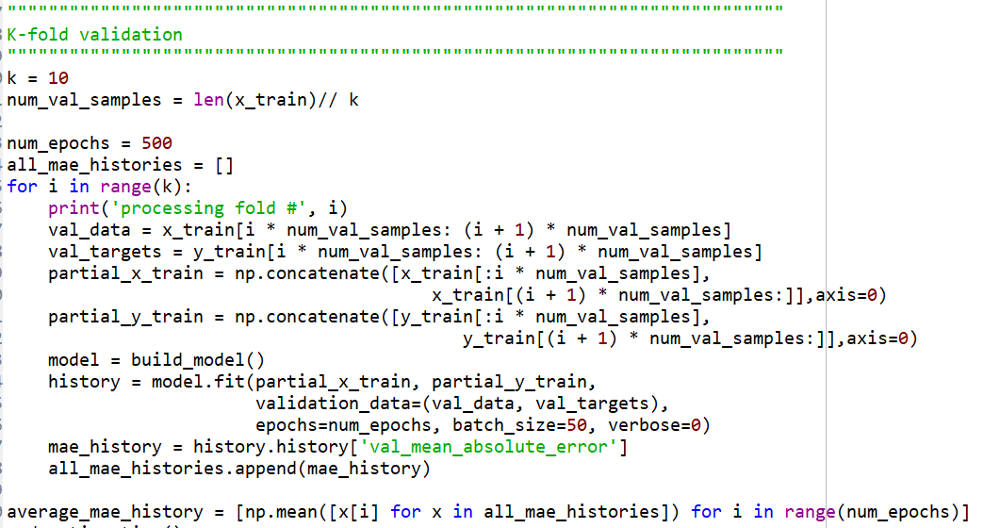

To evaluate my network while adjusting its parameters, the data was also split into a training set and a validation set. The best solution in such solution is to use K-Fold cross-validation. Normally, K is suggested equal to 5 or 10. The K-Fold training method is splitting the available training data into K partitions, implementing K identical models, and training each one on K-1 partitions while evaluating on the remaining partition. After validating each model selected, I applied the final production model on all of the training data with the best model.

1. **Your result in terms of appropriate metrics for the objective and problem**

Mean Absolute Error measures the average magnitude of the errors in a set of predictions. Since MSE already worked as the loss function, it’s prevalent to take MAE as a metric. In the red wine quality prediction scenario, MAE quantifies how close predictions are to the eventual outcomes.

The final test MAE result of the final model is 0.097, which means nearly 91% of the wine quality predictions are correct.

**A copy of my code**

# -*- coding: utf-8 -*-

"""

Created on Tue Feb 19 10:37:29 2019

@author: megan

"""

"""""""""""""""""""""""""""""""""""""""""""""""""""""""""""""""""""""""""""

Import Libraries Section

"""""""""""""""""""""""""""""""""""""""""""""""""""""""""""""""""""""""""""

from keras.models import Sequential

from keras.layers import Dense

from sklearn import preprocessing

from sklearn.model_selection import train_test_split

import matplotlib.pyplot as plt

import numpy as np

import pandas as pd

import time

import sys

if "C:\\My_Python_Lib" not in sys.path:

sys.path.append("C:\\My_Python_Lib")

"""""""""""""""""""""""""""""""""""""""""""""""""""""""""""""""""""""""""""

Load Data Section

"""""""""""""""""""""""""""""""""""""""""""""""""""""""""""""""""""""""""""

start = time.time()

data = pd.read_csv("winequality-red.csv",

delimiter=";", header=0,

names = ['f_acidity', 'v_acidity', 'citric Acid', 'r_sugar',

'chlorides', 'free_so2',

'total_so2', 'density', 'pH',

'sulphates', 'alcohol', 'quality'])

x_vars = ['f_acidity', 'v_acidity', 'citric Acid', 'r_sugar', 'chlorides',

'free_so2','total_so2', 'density', 'pH', 'sulphates', 'alcohol']

y_vars = ['quality']

"""""""""""""""""""""""""""""""""""""""""""""""""""""""""""""""""""""""""""

Pretreat Data Section

"""""""""""""""""""""""""""""""""""""""""""""""""""""""""""""""""""""""""""

x_data = data[x_vars]

y_data = data[y_vars]

print (len(x_data))

print (len(y_data))

x_data_MinMax = preprocessing.MinMaxScaler()

y_data_MinMax = preprocessing.MinMaxScaler()

x_data.values

x_data = np.array(x_data).reshape((len(x_data), 11))

y_data.values

y_data = np.array(y_data).reshape((len(y_data), 1))

x_data = x_data_MinMax.fit_transform(x_data)

y_data = y_data_MinMax.fit_transform(y_data)

x_train, x_test, y_train, y_test = train_test_split(x_data, y_data, test_size=0.33, random_state=7)

x_train.mean(axis=0)

y_train.mean(axis=0)

x_test.mean(axis=0)

y_test.mean(axis=0)

print(x_train.shape)

"""""""""""""""""""""""""""""""""""""""""""""""""""""""""""""""""""""""""""

Define Model Section - RMSPROP

"""""""""""""""""""""""""""""""""""""""""""""""""""""""""""""""""""""""""""

def build_model():

model = Sequential()

model.add(Dense(12, activation='relu', input_shape=(x_train.shape[1],)))

model.add(Dense(12, activation='relu'))

model.add(Dense(1))

model.compile(loss='mean_squared_error', optimizer='rmsprop', metrics=['mae'])

return model

"""""""""""""""""""""""""""""""""""""""""""""""""""""""""""""""""""""""""""

K-fold validation

"""""""""""""""""""""""""""""""""""""""""""""""""""""""""""""""""""""""""""

k = 10

num_val_samples = len(x_train)// k

num_epochs = 500

all_mae_histories = []

for i in range(k):

print('processing fold #', i)

val_data = x_train[i * num_val_samples: (i + 1) * num_val_samples]

val_targets = y_train[i * num_val_samples: (i + 1) * num_val_samples]

partial_x_train = np.concatenate([x_train[:i * num_val_samples],

x_train[(i + 1) * num_val_samples:]],axis=0)

partial_y_train = np.concatenate([y_train[:i * num_val_samples],

y_train[(i + 1) * num_val_samples:]],axis=0)

model = build_model()

history = model.fit(partial_x_train, partial_y_train,

validation_data=(val_data, val_targets),

epochs=num_epochs, batch_size=50, verbose=0)

mae_history = history.history['val_mean_absolute_error']

all_mae_histories.append(mae_history)

average_mae_history = [np.mean([x[i] for x in all_mae_histories]) for i in range(num_epochs)]

end = time.time()

print(end - start)

"""""""""""""""""""""""""""""""""""""""""""""""""""""""""""""""""""""""""""

Show & Plot output Section

"""""""""""""""""""""""""""""""""""""""""""""""""""""""""""""""""""""""""""

print(np.mean(average_mae_history))

print(min(average_mae_history))

print('Epoch for min Mae:', average_mae_history.index(min(average_mae_history)))

plt.plot(range(1, len(average_mae_history) + 1), average_mae_history)

plt.xlabel('Epochs')

plt.ylabel('Validation MAE')

plt.show()

"""""""""""""""""""""""""""""""""""""""""""""""""""""""""""""""""""""""""""

Final Model Application

"""""""""""""""""""""""""""""""""""""""""""""""""""""""""""""""""""""""""""

model = build_model()

test_mae_score = []

model.fit(x_train, y_train, epochs=80, batch_size=16, verbose=0)

test_mse_score, test_mae_score = model.evaluate(x_test, y_test)

print(test_mae_score)